**Objective Question:**

1. What is the total no. of tables present in the data?

Ans.20 Tables present in data.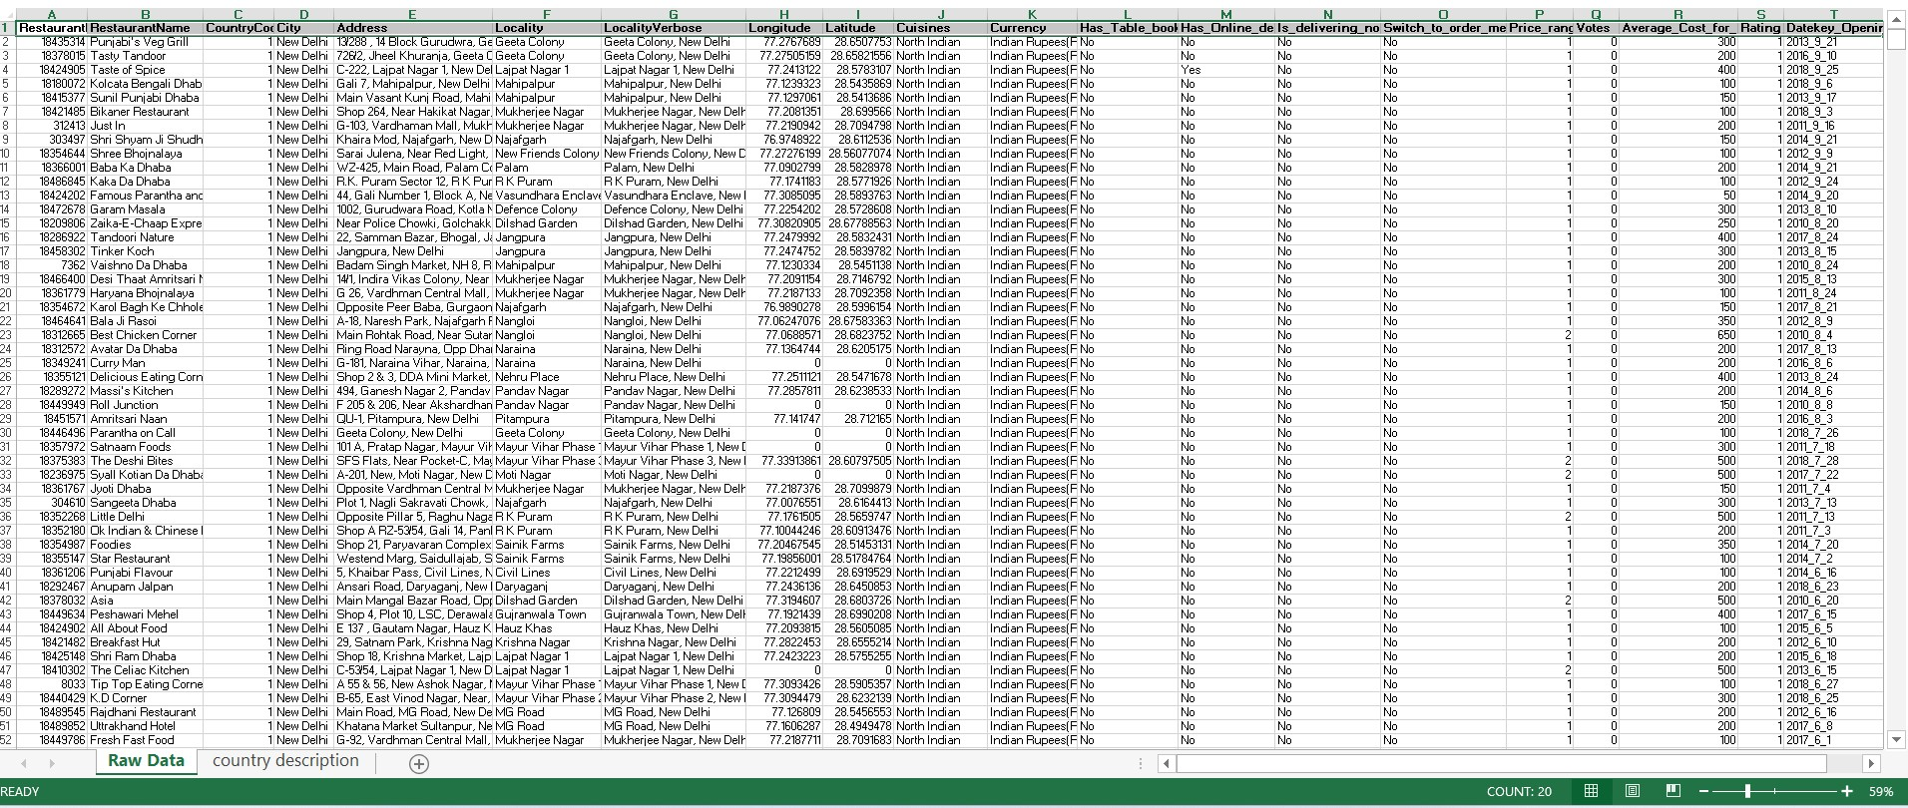

2. What is the total no. of attributes present in the data?

Ans.The total number of attributes present in the data is 20.

"Raw Data" and "country description." The "Raw Data" sheet contains the primary dataset with **20 attributes** that describe various restaurant details.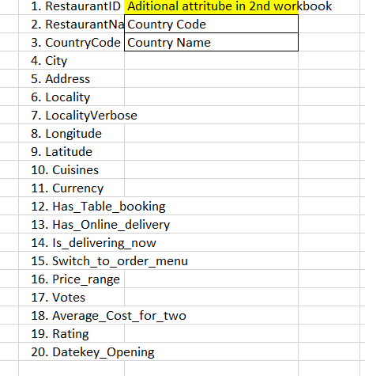

Additionally, **2 attributes** on country Description.

3.How many categorical columns are there in the data? [Search about categorical and continuous data, and try to answer this question].

Ans.**Categorical data**:Represent the non-numeric or qualitative values.

This is divided into Two Part:

1**.Nominal** Ex.colors, names.

2.**Ordinal** Ex.ratings like low, medium, high.

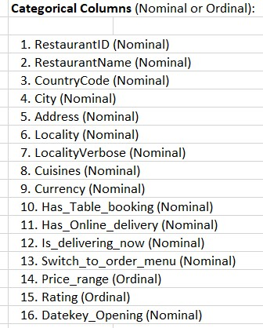

**Continuous data**:Represent the numeric values that can take any value within a range, often measured, and can include decimals.

Ex.longitude, latitude, or average cost.

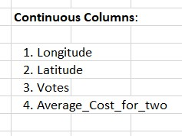

Hence,There are **16 categorical** columns in the data.

4.The data consists of some inconsistent and missing values so ensure that the data used for further analysis is cleaned.

Ans.Done in Worksheet.

5.Using the LookUp functions, fill up the countries in the original data using the country code.

Ans.Done in Worksheet.

6.Create a table to represent the number of restaurants opened in each country.

Ans.Done in Worksheet.

7.Also, the management wants to look at the number of restaurants opened each year, so provide them with something here.

Ans.Done on Worksheet.

8.What is the total number of restaurants in India in the price range of 4?

Ans.Done in Worksheet.

9.What is the average number of voters for the restaurants in each country according to the data?

Ans.Done in Worksheet.

10.Calculate the average rating for all the restaurants that have price_range < 4 and provide online delivery. Use only the “IF” function, Logical Operators, and Aggregation functions to solve this problem. **[Note: Don’t use Conditional aggregation in this question.]**

Ans.Done in Worksheet.

11.Using Conditional formatting highlight the rows of restaurants that are located in the countries or cities that you’ve suggested to the management for opening

Ans.Done in Worksheet.

12.Create a new customized price column that consists of the abbreviation/symbol of the currency along with the Average_cost_for_two value. [Use string operations to do this task]

Ans.Done in Worksheet.

**13.** How can you create an array formula in Excel or Google Sheets to count the number of restaurants listed that do not offer online delivery, are in the lowest price range, and have an average cost for two people less than or equal to 250 Indian Rupees?

Ans.Done in Worksheet.

**Subjective Question:**

1. Suggest a few countries where the team can open newer restaurants with lesser competition. Which visualization/technique will you use here to justify the suggestions?

**Visualization:**

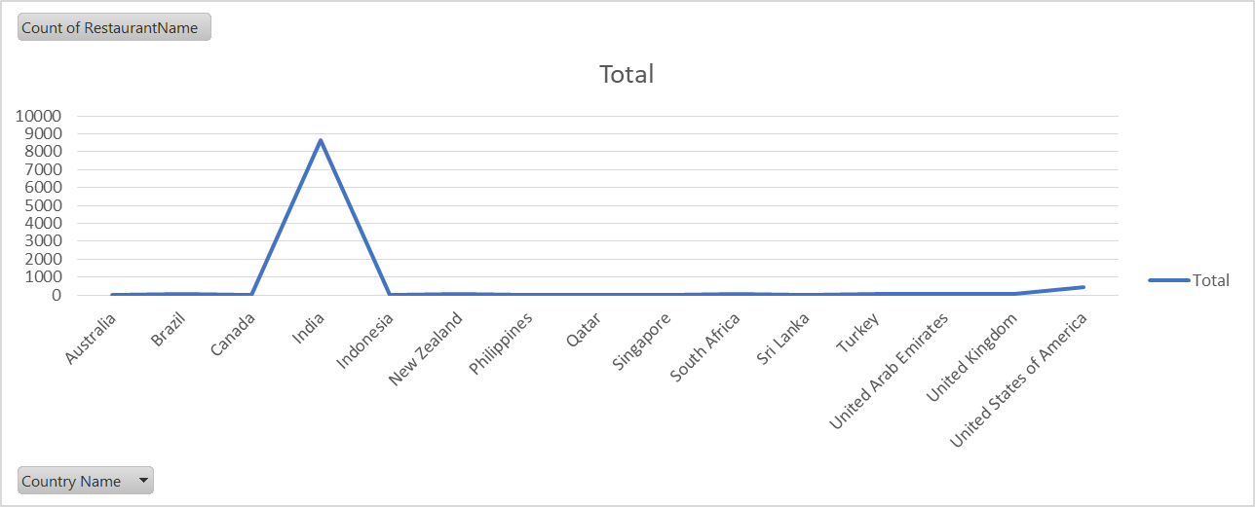

1. Come up with the names of States and cities in the suggested countries suitable for opening restaurants.

**Visualization:**

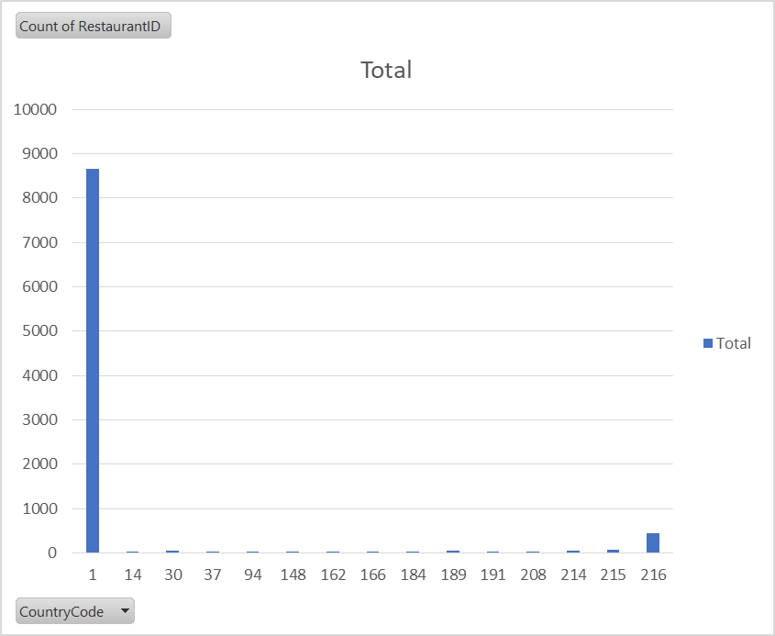

1. According to the countries you suggested, what is the current quality regarding ratings for restaurants that are open there?

**Visualization:**

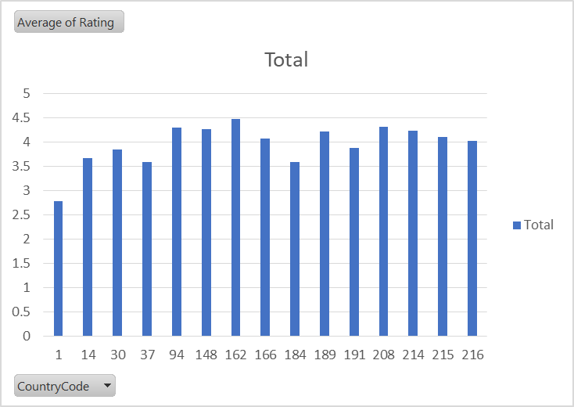

1. Also, what is the current expenditure on food in the suggested countries, so we can keep our financial expenditure in control?

**Visualization:**

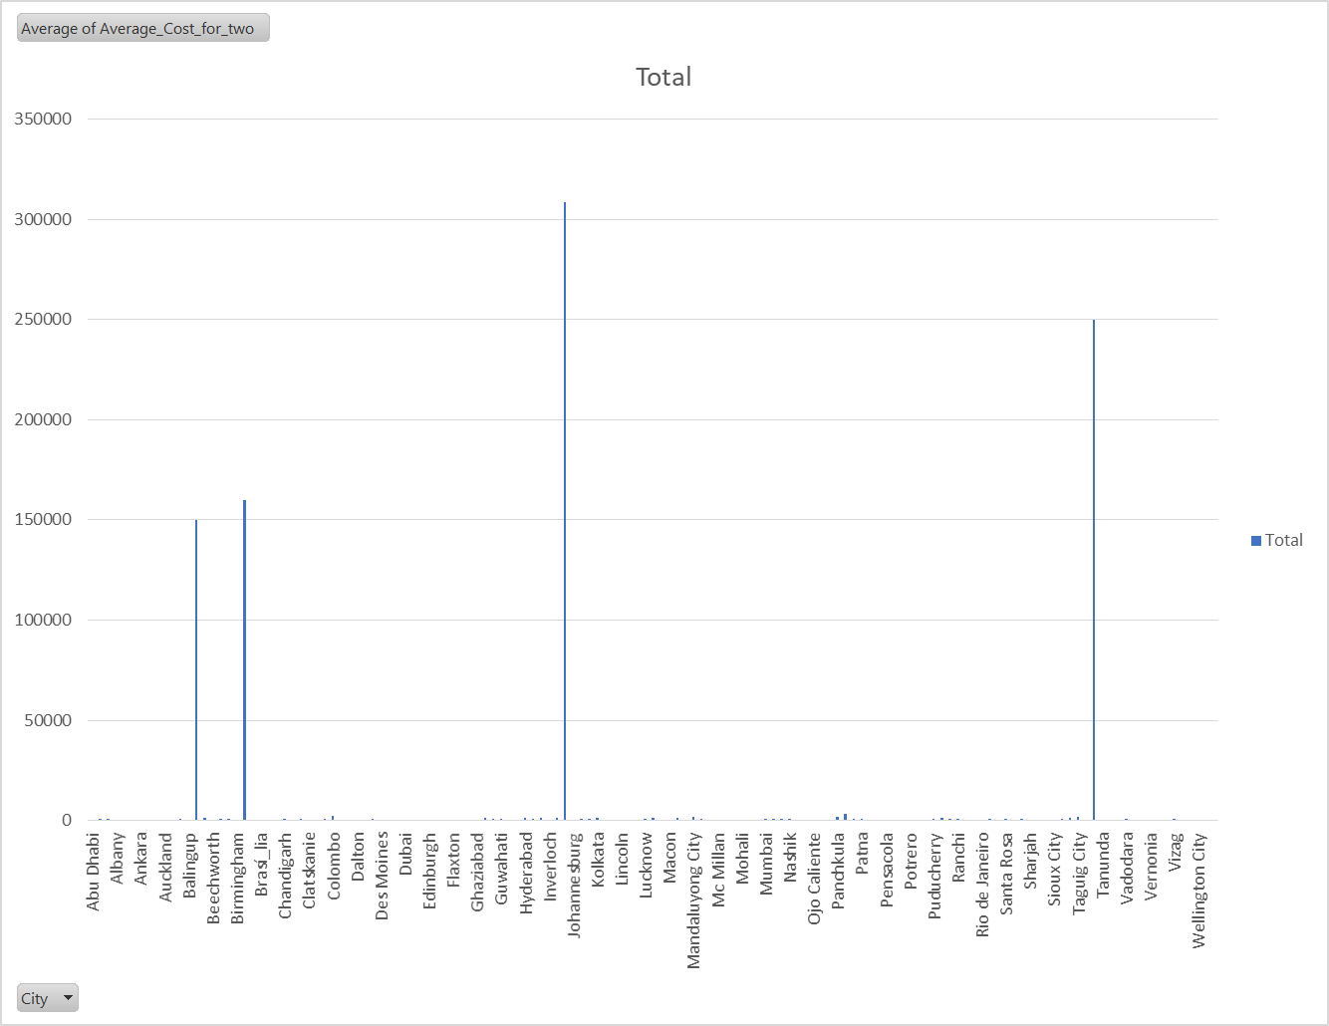

1. Come up with the names of restaurants from the recommended states that are our biggest competitors and also those that are rated in the lower brackets, i.e. 1-2 or 2-3.

**Visualization:**

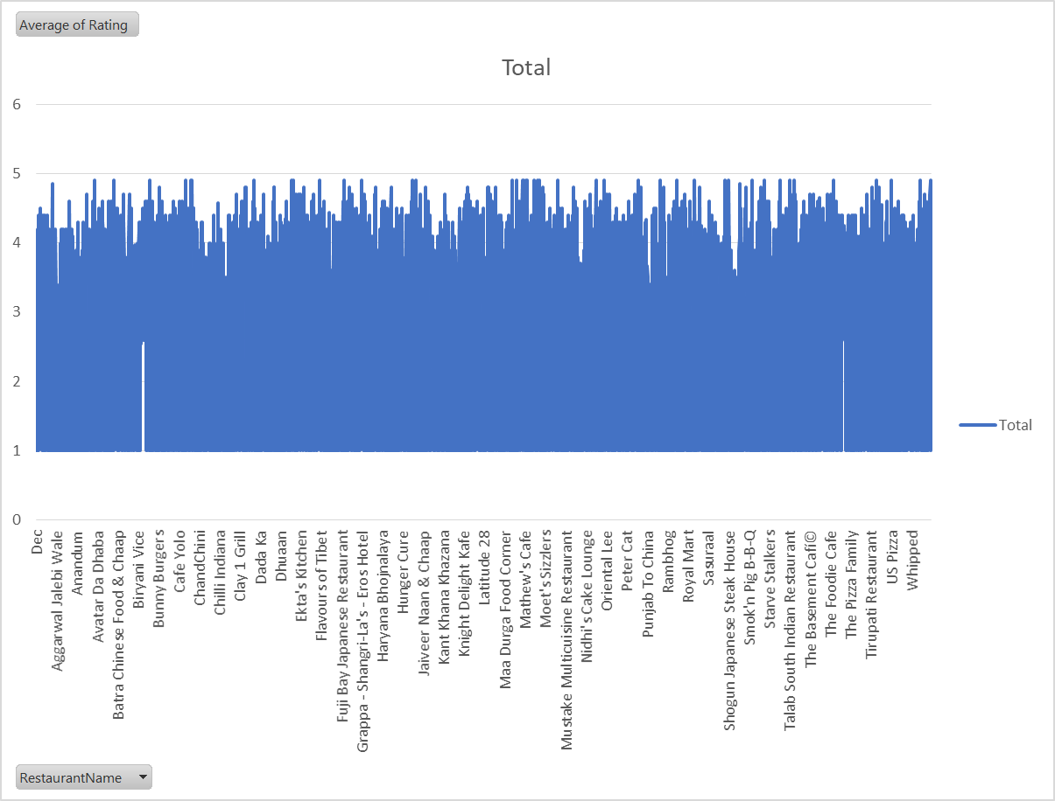

1. Which cuisines should we focus on in the newer restaurants to get better feedback? Does the choice of cuisines affect the restaurant ratings?

**Visualization:**

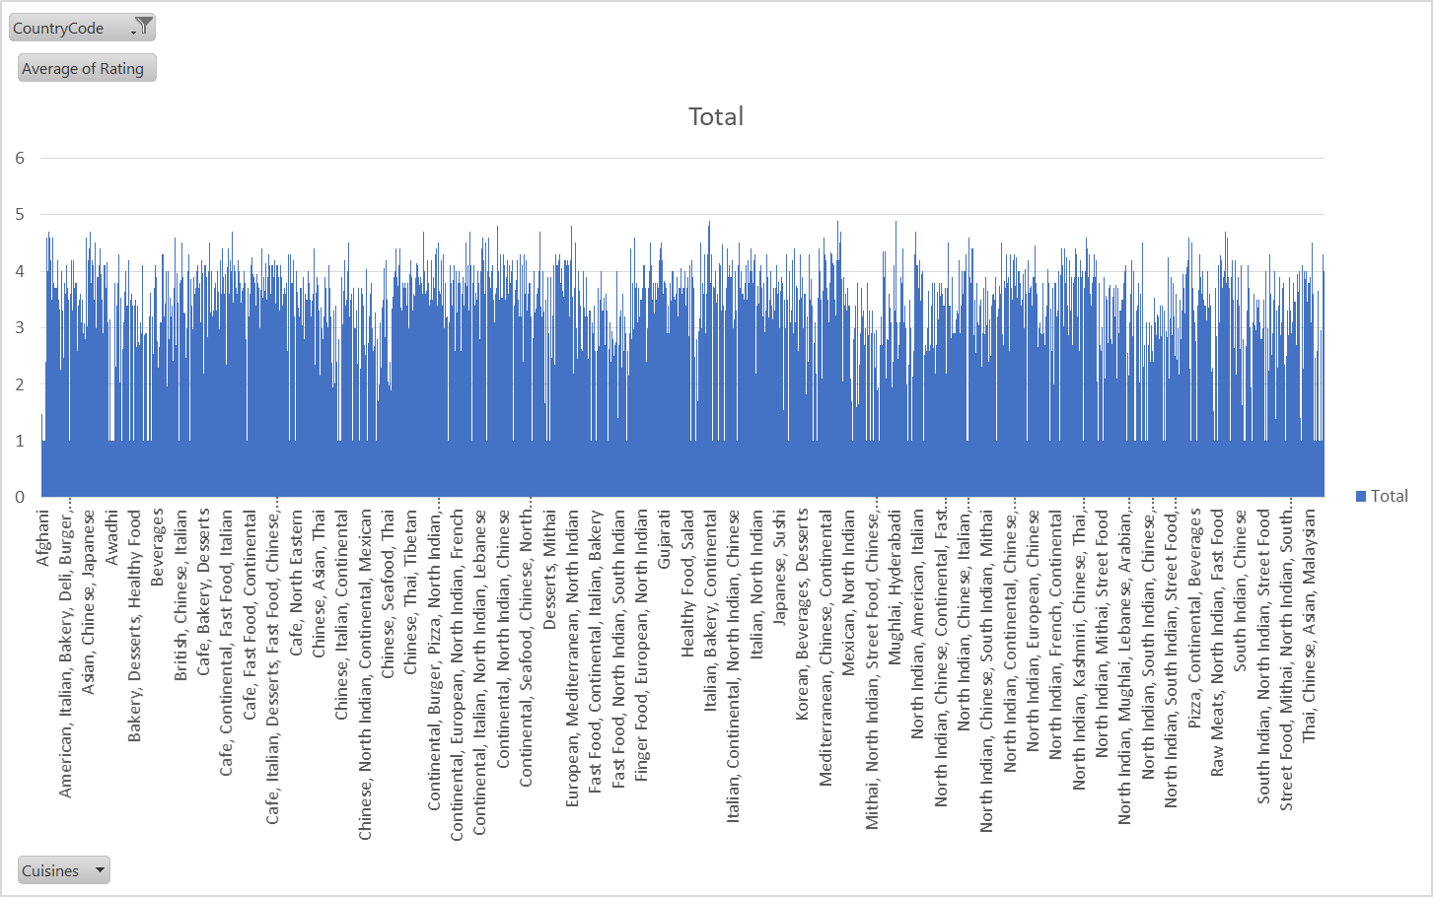

1. According to our current data, should we go for online delivery and table booking? Does that affect the customer’s ratings?

**Visualization**

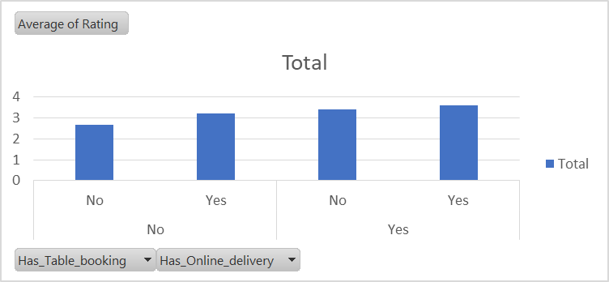

1. Should the team keep the rate of cuisines higher? Will that affect the feedback? According to our data are the rates of cuisines and ratings, correlated?

**Visualization:**

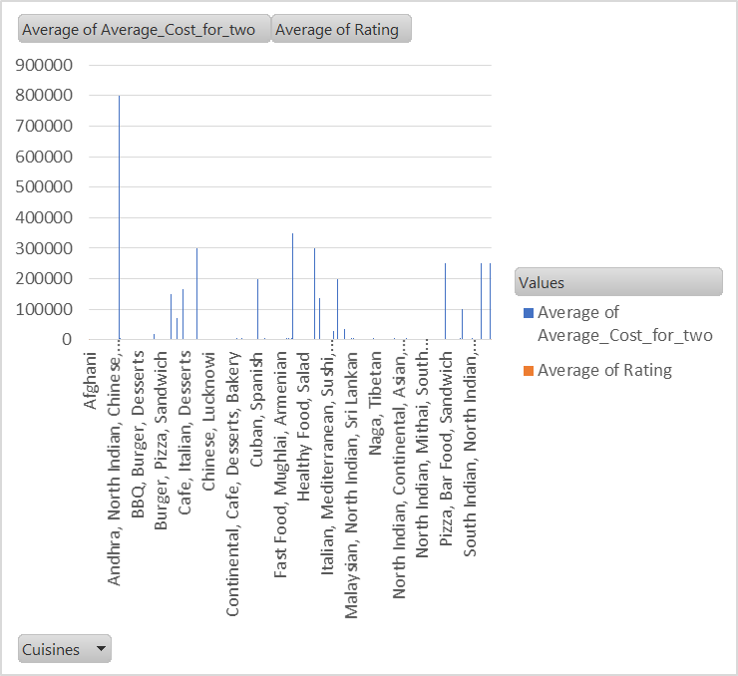

1. What is the distribution of the number of restaurants of different price ranges in all the countries?

**Visualization:**

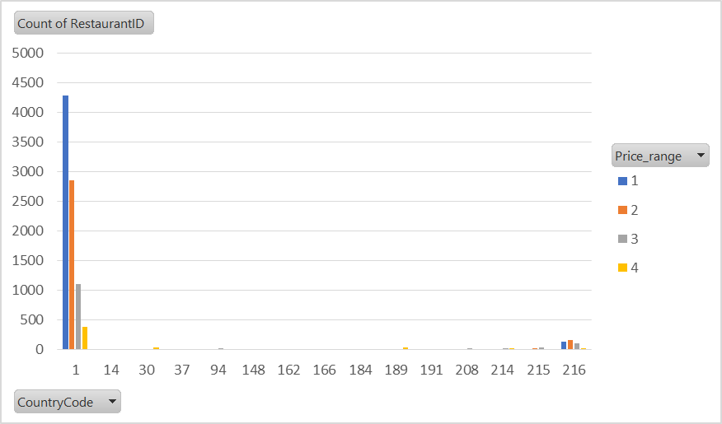

1. Explain your approach in brief for suggesting countries/cities in order to open new restaurants, if the objective and subjective questions would have not been given to assist you. **[you have to give bullet pointers in order to answer this question]**

**1. Map Out Restaurant Density and Competition**

* I would examine the number of restaurants listed in each country and city to get a sense of where the market is saturated and where it’s less crowded.
* Countries and cities with fewer restaurants indicate less direct competition, making them promising for new openings.

**2. Assess Market Size and Urbanization**

* I’d look at underlying population and urbanization—large, metropolitan cities suggest more potential customers.
* Preference would be given to cities that are commercial or tourism hubs, which typically support more diverse dining demand.

**3. Evaluate Customer Experience and Quality**

* Average customer ratings in each country or city would be analyzed.
* Markets where existing restaurants have lower ratings might offer an opportunity for us to introduce higher-quality dining options and quickly stand out.

**4. Analyze Price Sensitivity and Spending Patterns**

* By analyzing the average cost for two people in different regions, I’d understand local spending habits.
* This helps match our pricing model to what’s already working, and identify if there’s appetite for more premium or value-oriented concepts.

**5. Identify Cuisines With Best Reception**

* I’d break down cuisine popularity and their associated ratings by city and country.
* Prioritizing cuisines with consistently high ratings in target areas would help us shape a menu that’s more likely to be received well.

**6. Consider Operational Trends**

* I’d check how common and impactful features like online delivery and table booking are by region, using both the count of restaurants offering them and the corresponding average ratings.
* This helps us decide which services should be built into our business model from the start.

**7. Visualize and Present the Data**

* For transparency and decision support, I would use pivot tables and charts to highlight the current landscape—restaurant count, price distribution, and ratings—across different cities and countries.
* Geographic heat maps or stacked bar charts can reveal clear expansion opportunities.

**8. Factor in Local Culture and Culinary Gaps**

* Finally, I’d look for gaps between what’s popular locally and what’s missing.
* Emphasizing authenticity but also innovation, especially in cosmopolitan, diverse locations.